**Analysis On Overall Sustainability On No Poverty**

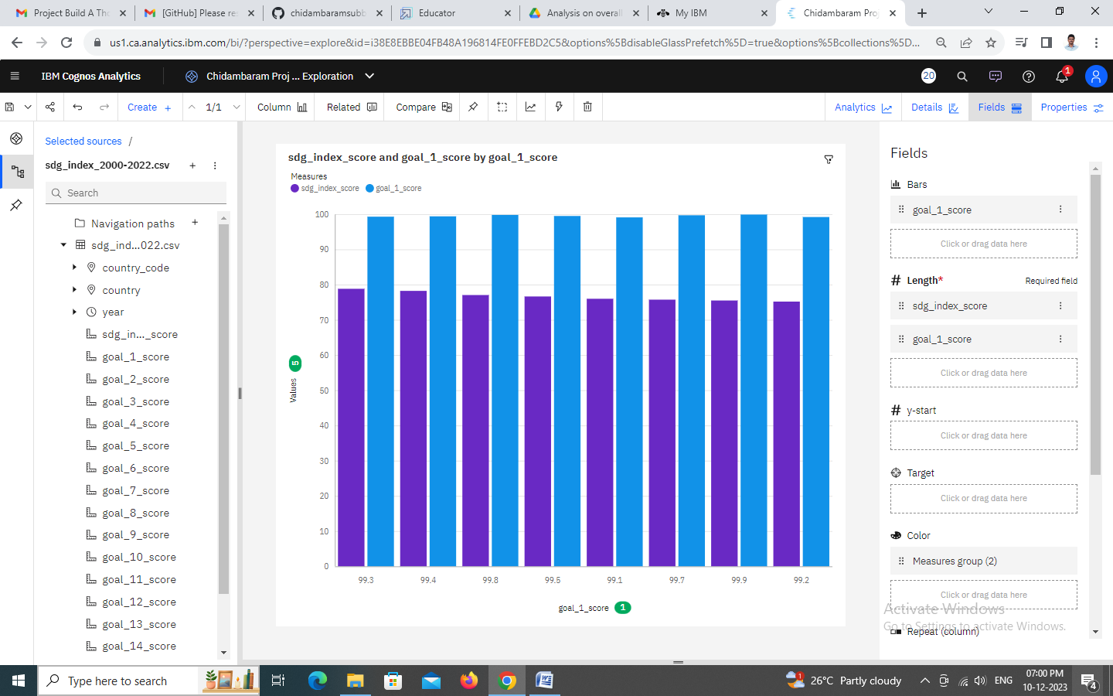

### Analysis Overall Sustainability On Quality Education

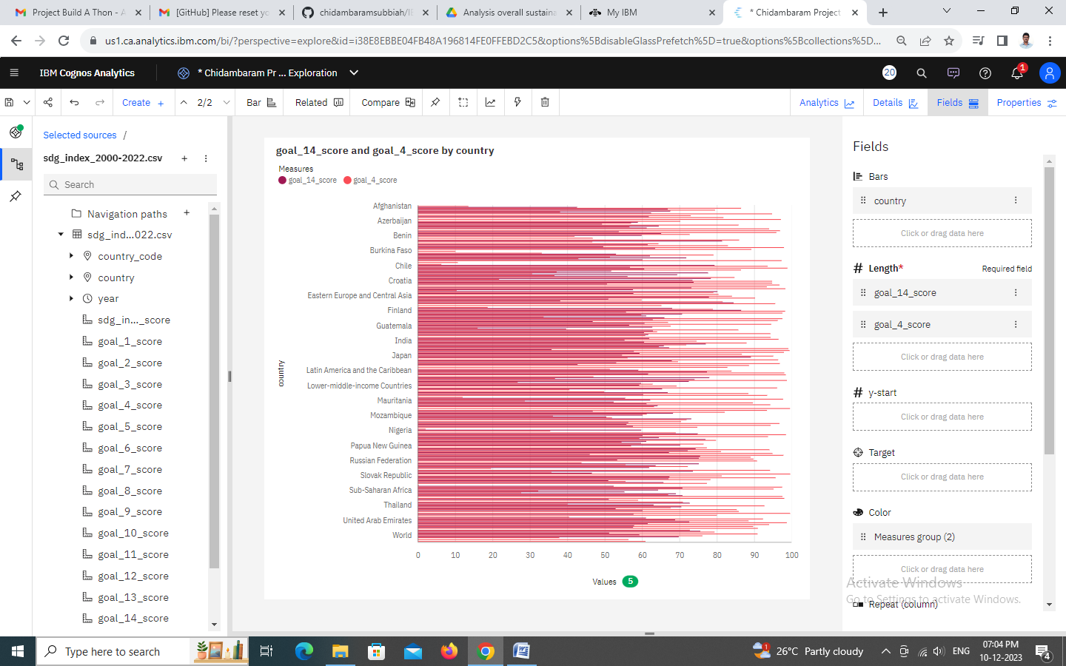

### Analysis On Overall Sustainability Life Below Water

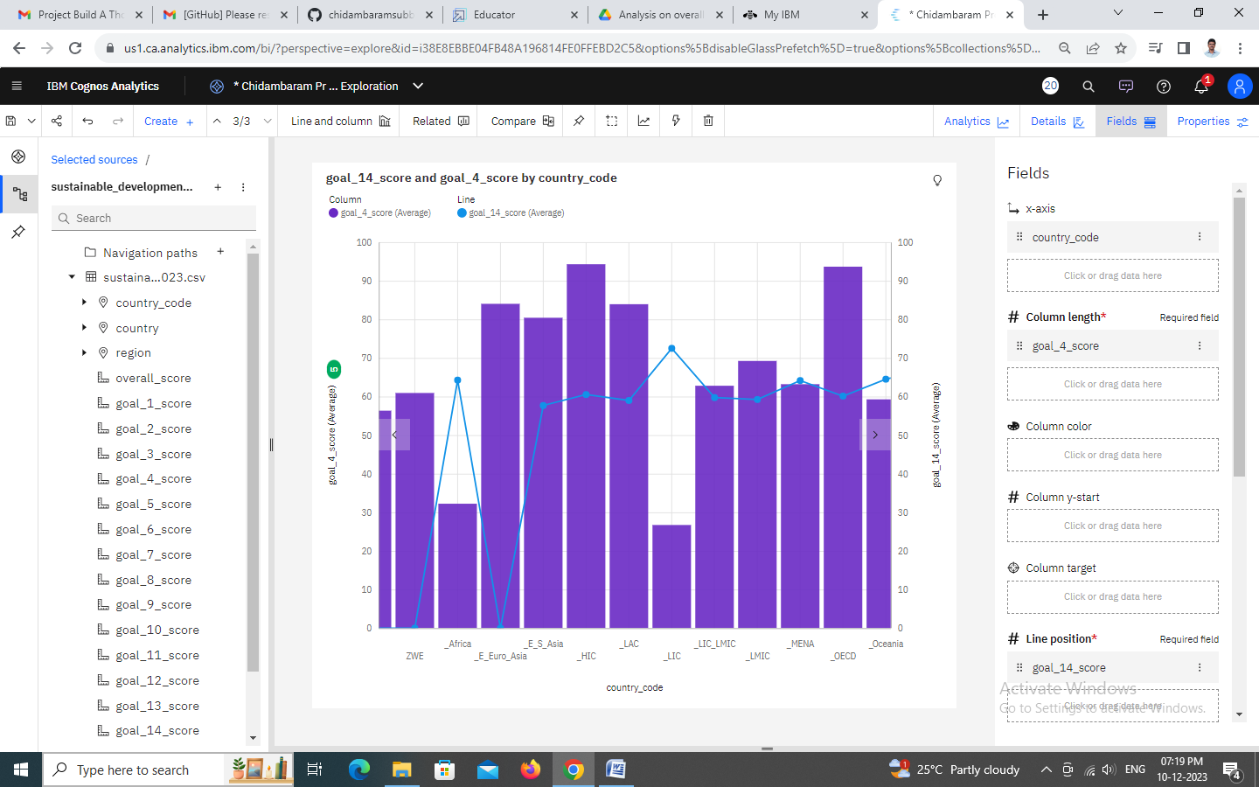

### Analysis On Overall Sustainability Partnerships For The Goals

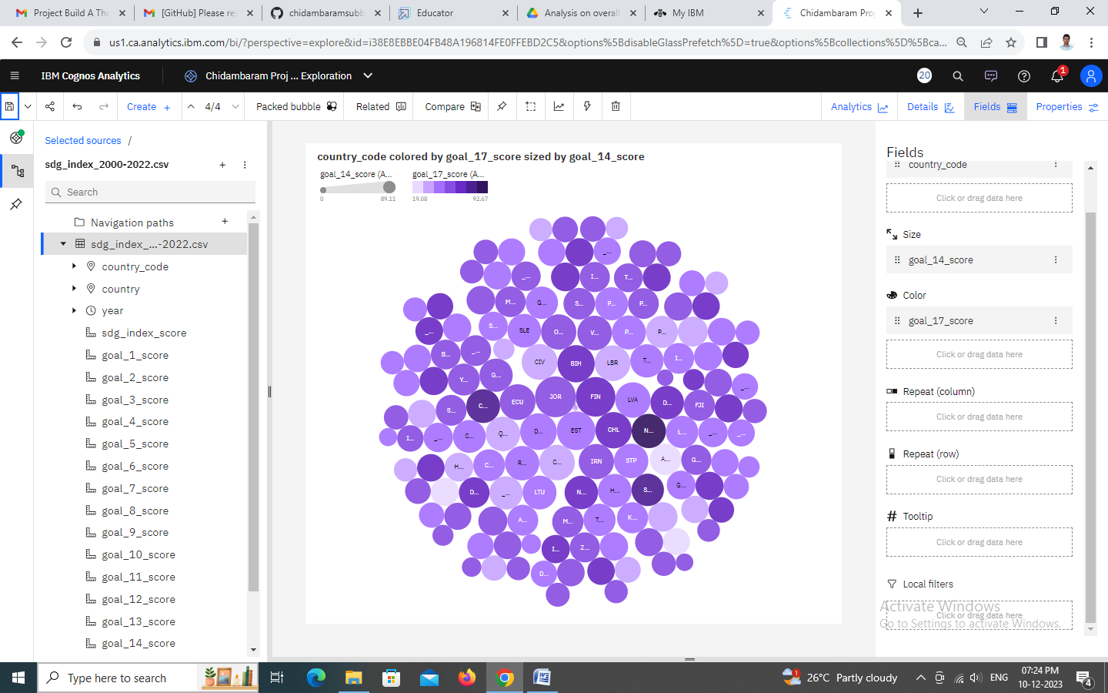

### Analysis On Overall Sustainability Industry, Innovation And Infrastructure

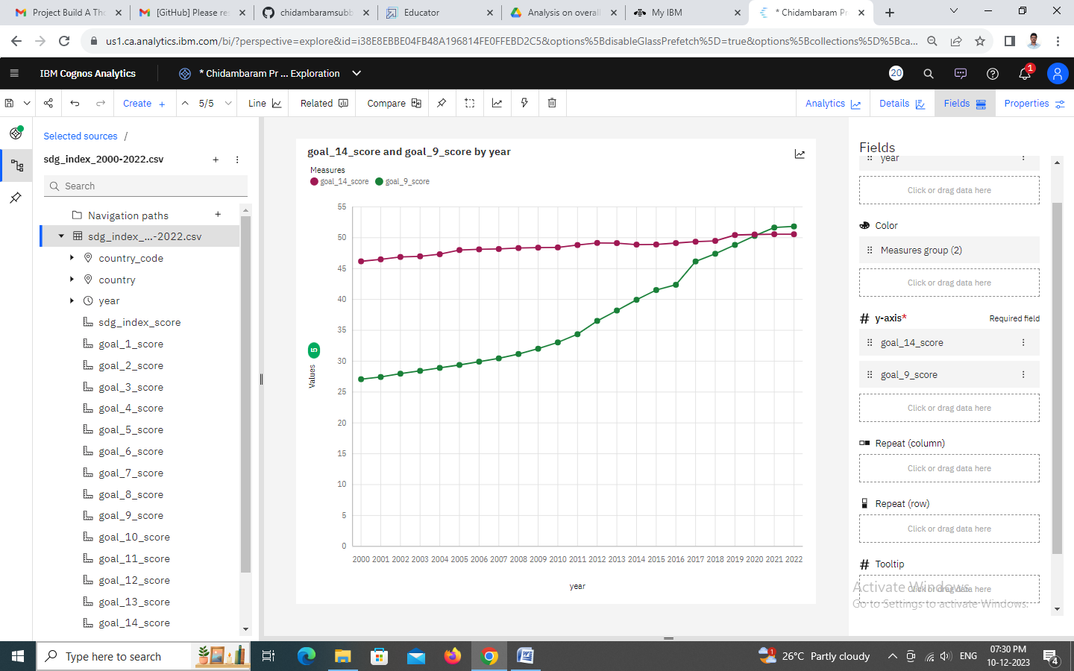

### Analysis On Overall Sustainability Life On Land

